|  |  |  |  |  |  |
| --- | --- | --- | --- | --- | --- |
| Date | 23-Nov-22 | | | Tester Name | Shahabuddin Syed |
| Environment | Penfax - Test | | | Login used |  |
| Operating System | Windows | Version: | Update: | | |
| Software Used | Edge | Version: | Update: | | |
| Not Applicable | Version: | Update: | | |
| Release version | 22.4.1 | | | | |
| Title | M11.04 – Project Estimates | | | | |
| Test Type | Regression | | | | |
| Test Scenario | Non-vested General 12-month member with different service types has high salary and age <35 | | | | |
|  |  | | | | |
| Expected Results |  | | | | |
| Pass/Fail | Pass | | | JIRA# | N/A |

Describe your steps with screenshots:

Login into Penfax application

Search for the member

Click on their stakeholder ID

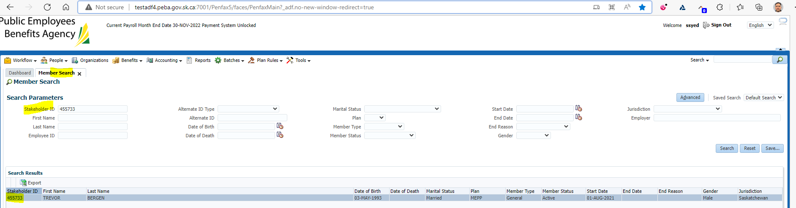

Click on Retirement Projection tab

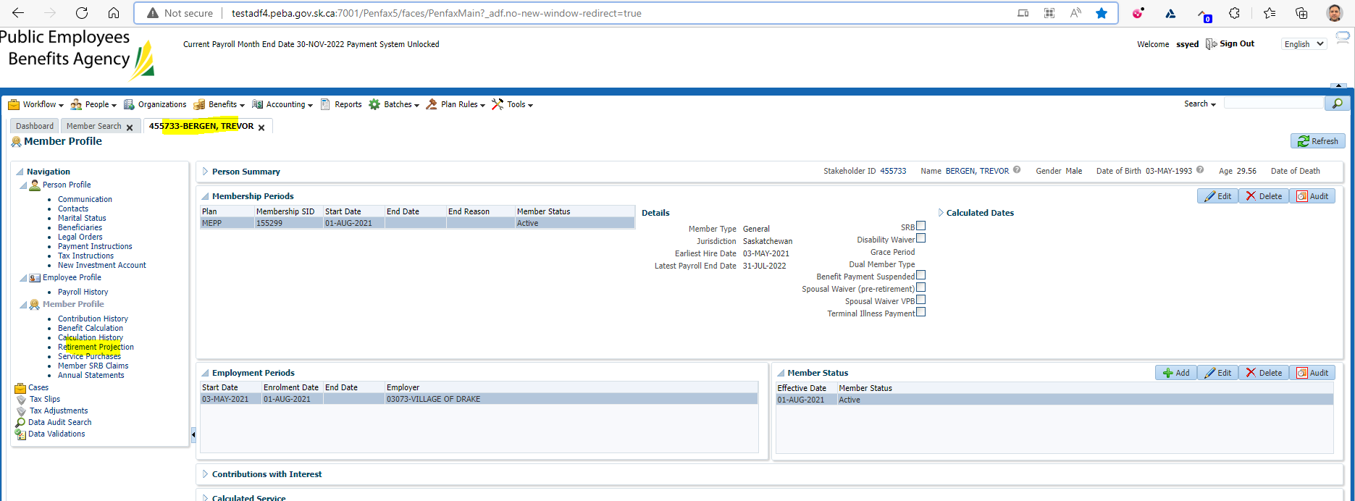

Click on Calculate Retirement Dates

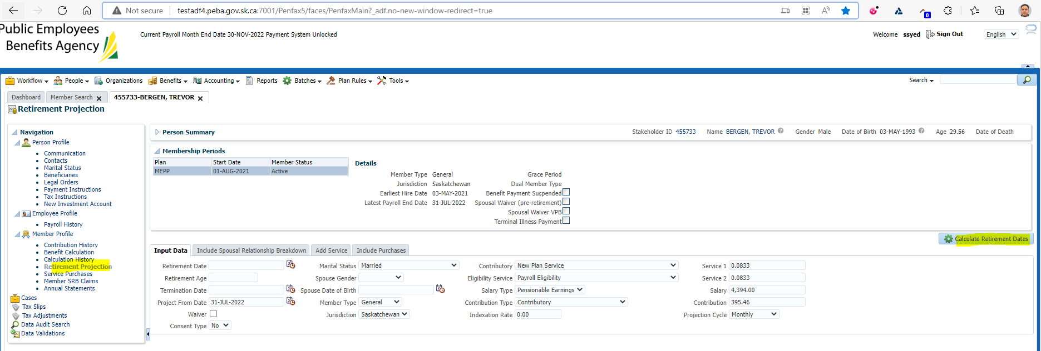

Should verify if there is conflict in Marital Status

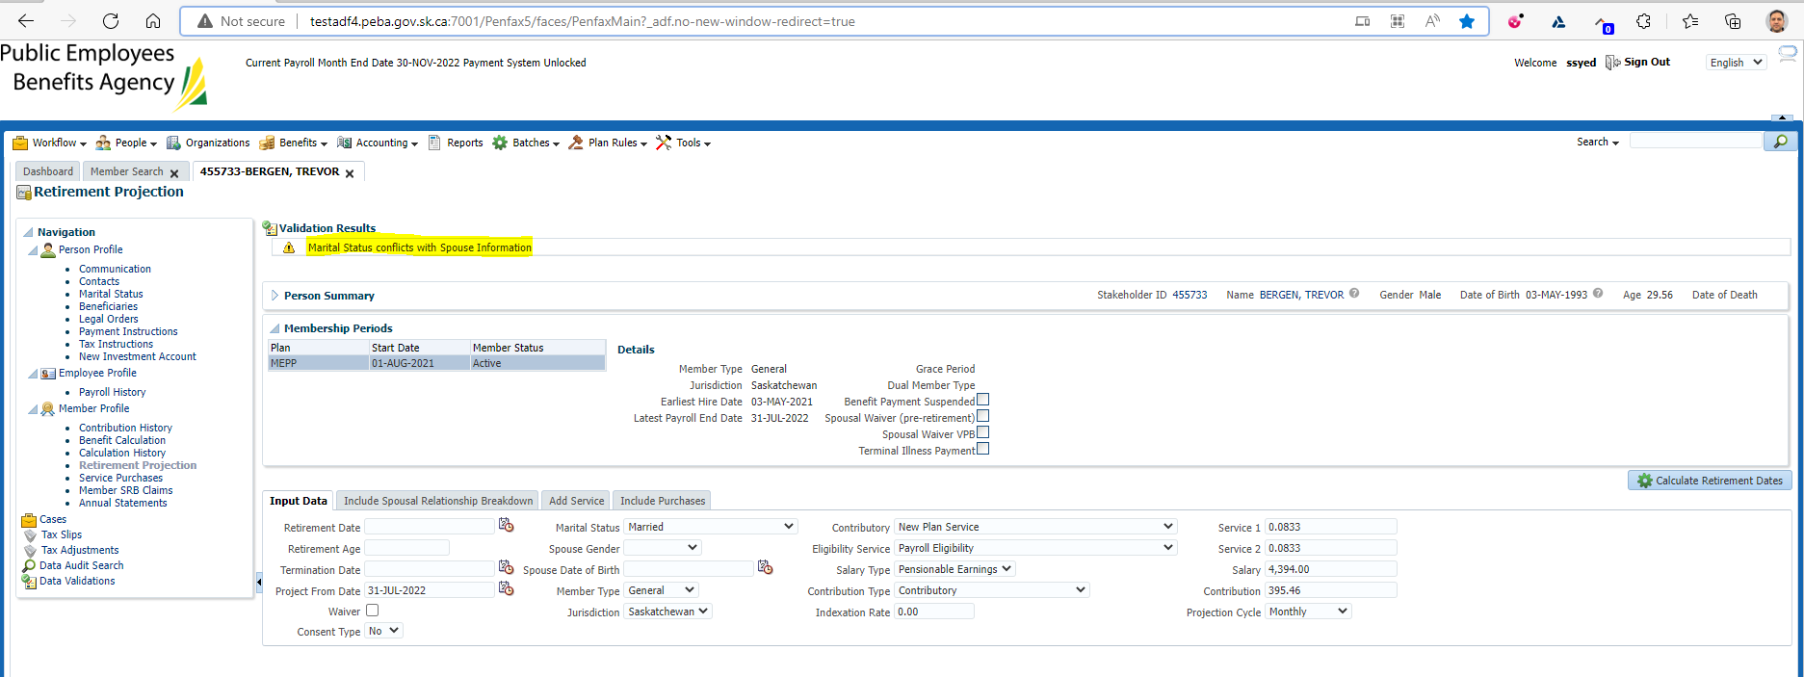

Then repeat the step again

Click on Calculate Retirement Dates

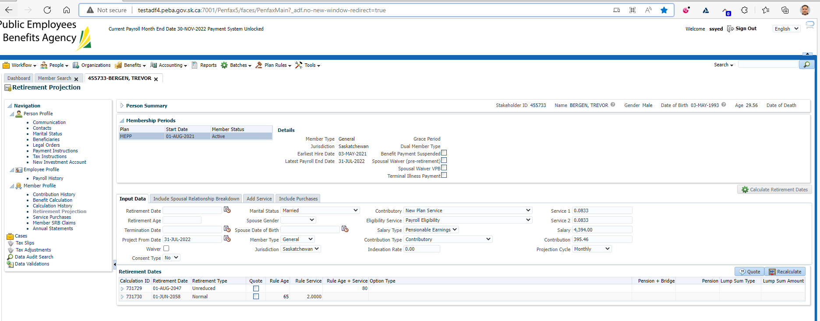

Need to click on Quote twice

Make sure it has been tick marked on the Quote button under Retirement Dates

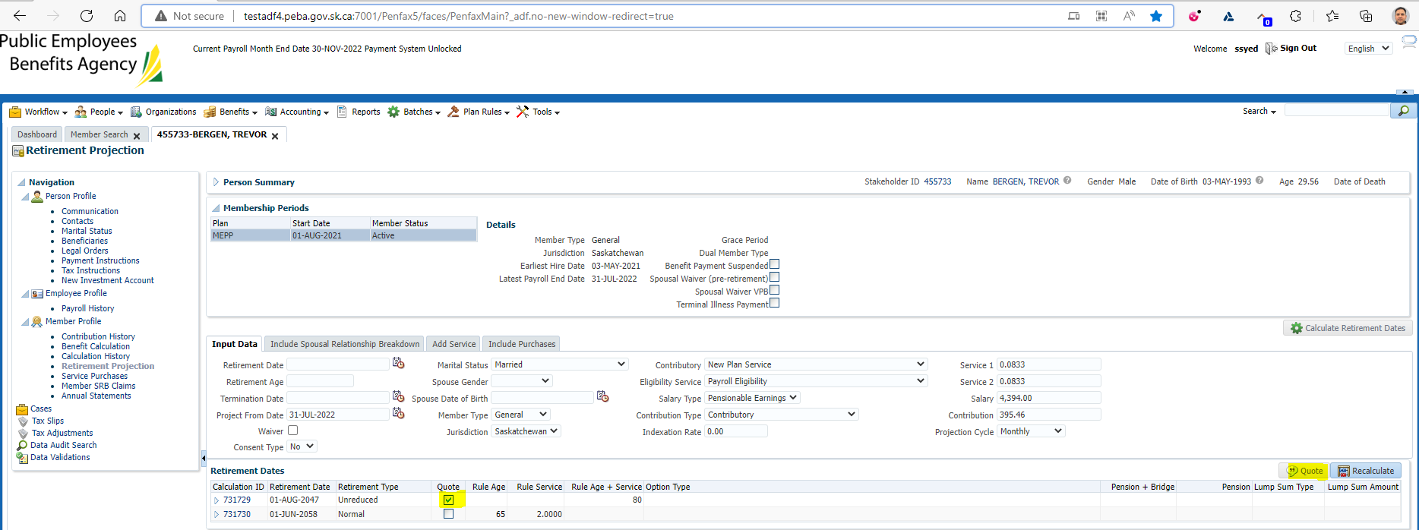

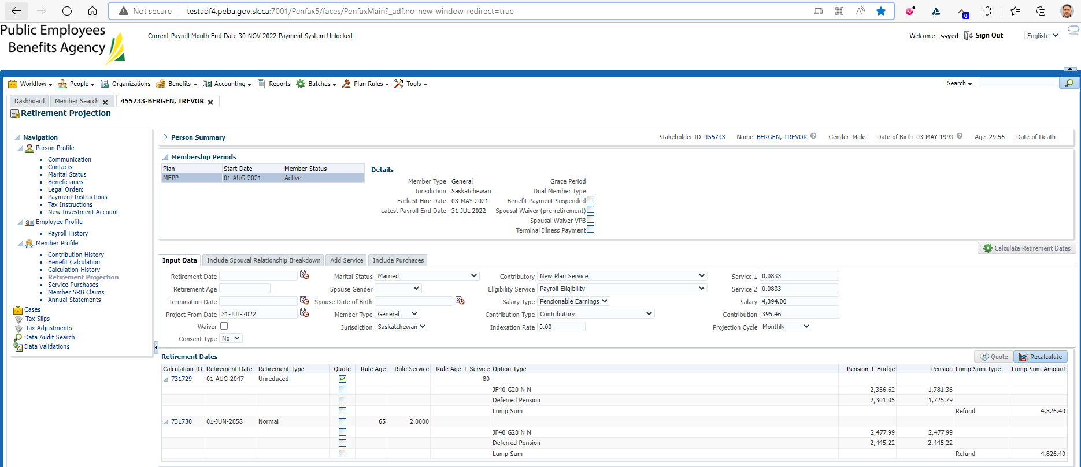

Comparison with Test1 Region

Login into Penfax application

Search for the member

Click on their stakeholder ID

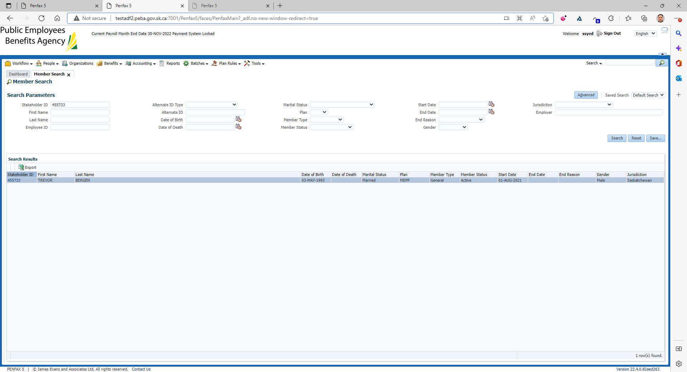

Click on Retirement Projection tab

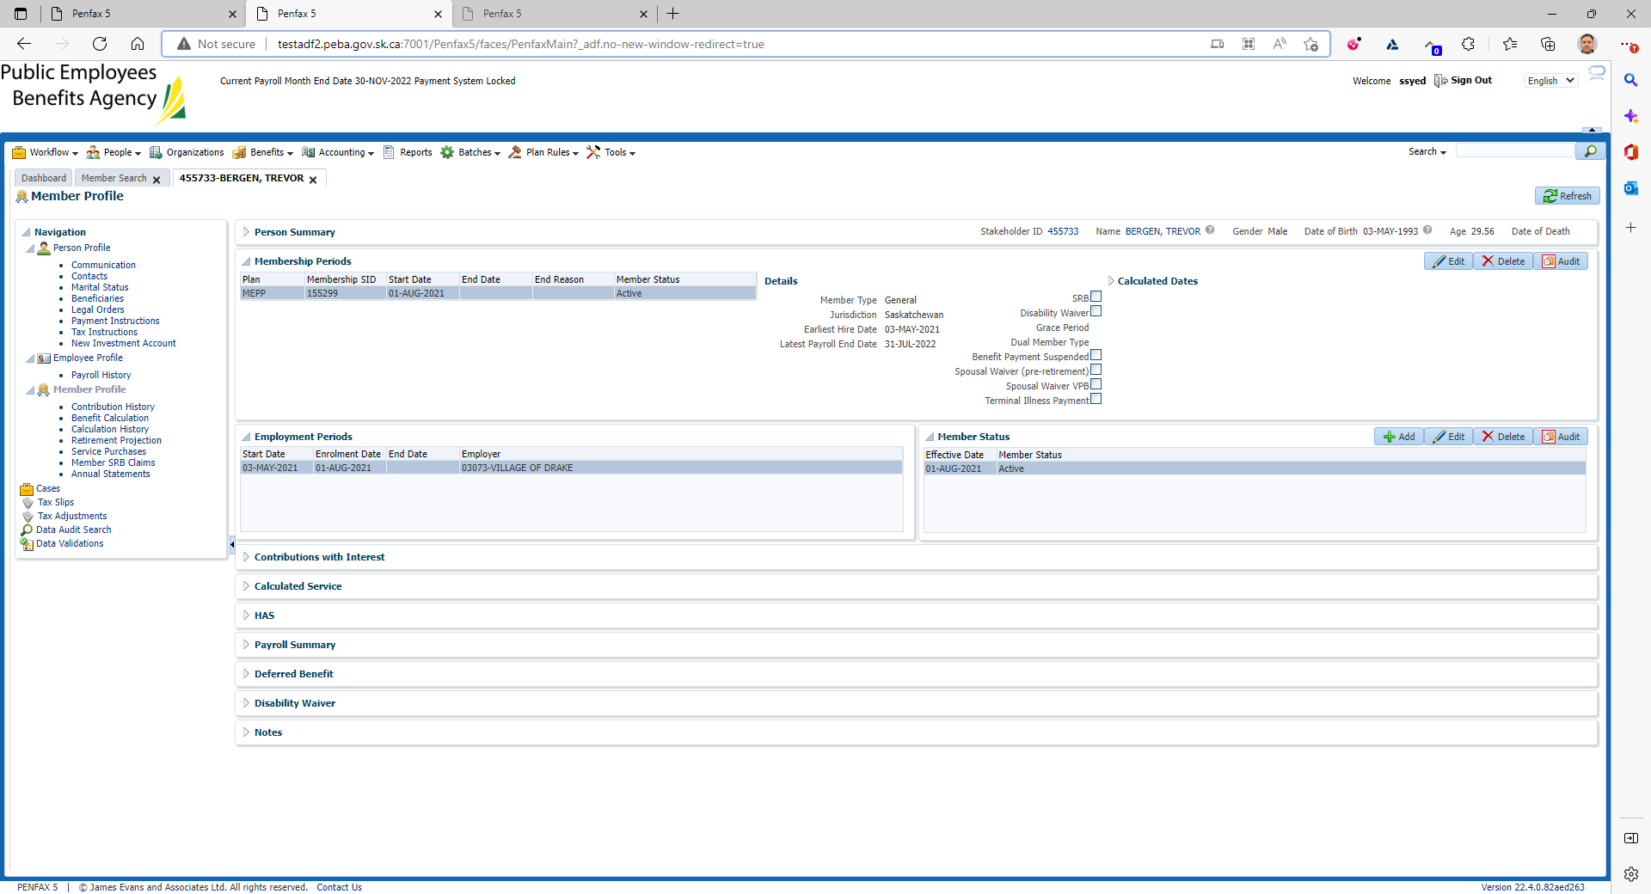

Click on Calculate Retirement Dates

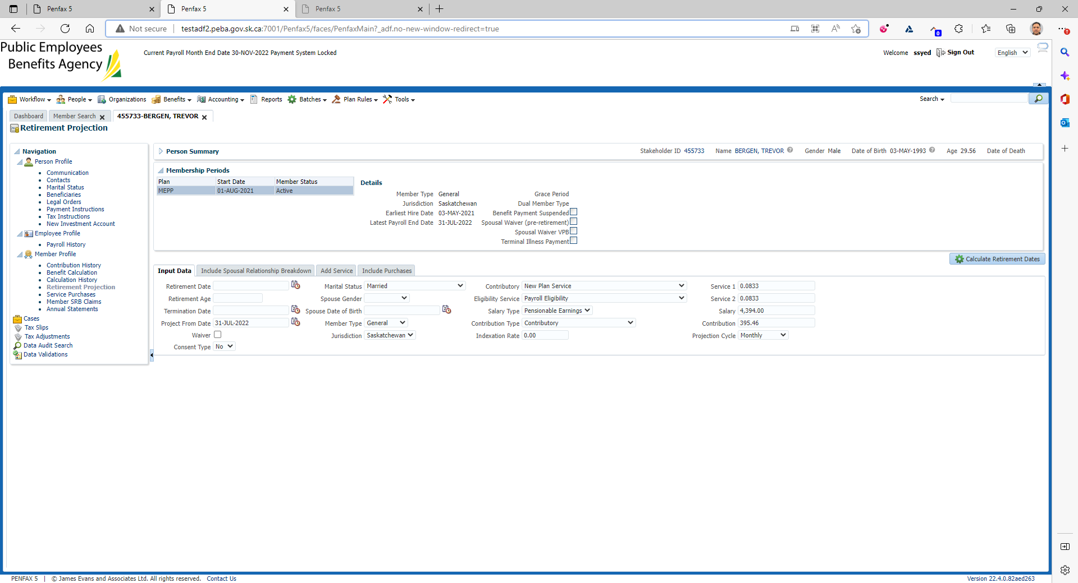

Should verify if there is conflict in Marital Status

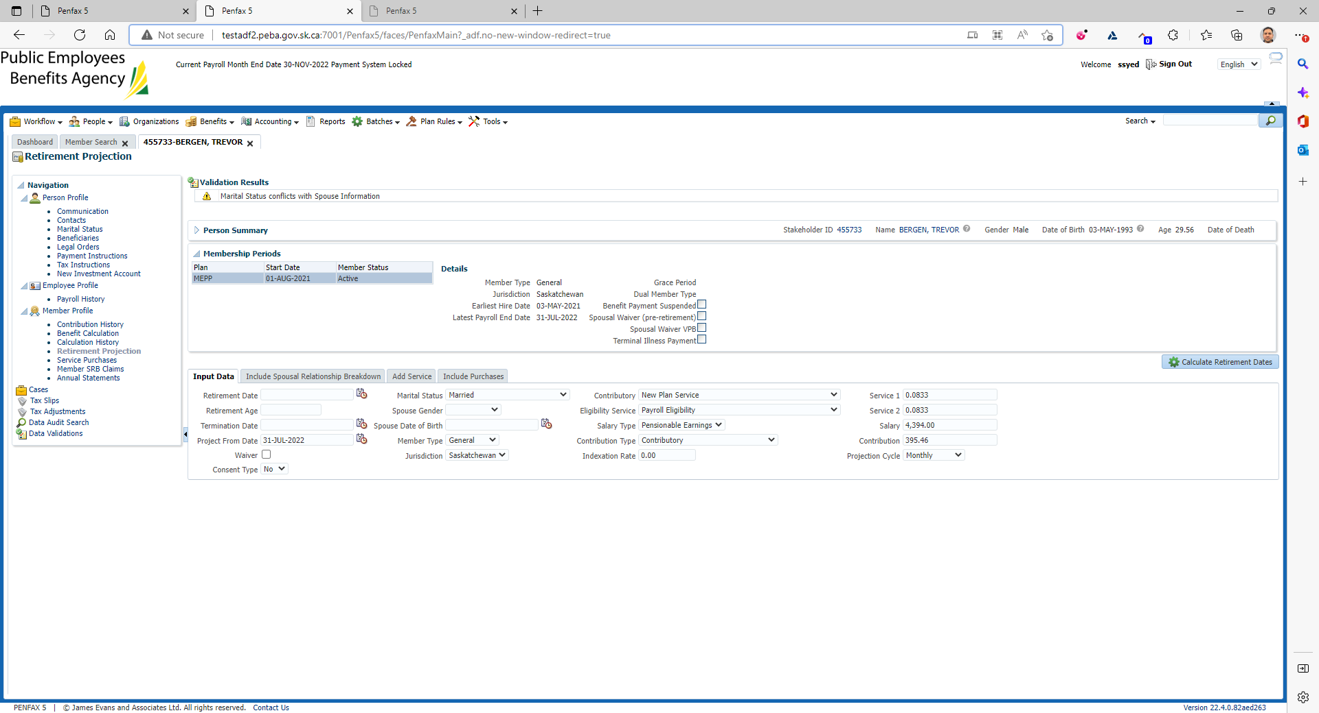

Then repeat the step again

Click on Calculate Retirement Dates

Make sure the comment is disappeared

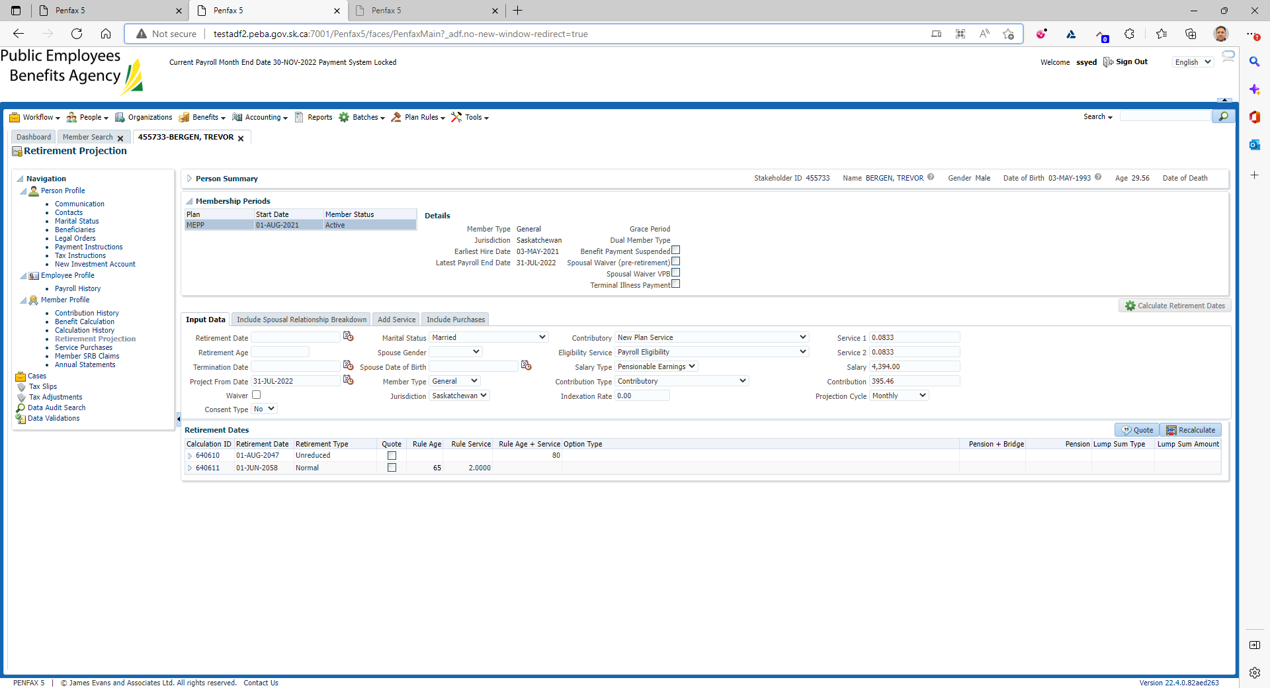

Need to click on Quote twice

Make sure it has been tick marked on the Quote button under Retirement Dates



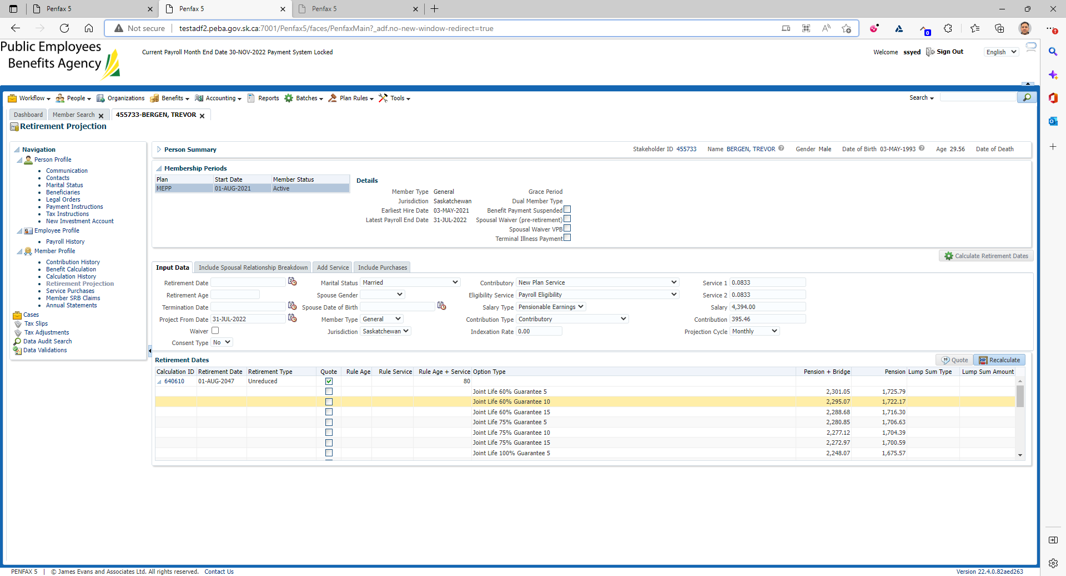

Comparison with Test1 region

